# Programing practice

# Q1.

package com.example.project;

public class Main1 {

public static void main(String[] args) {

System.out.println("Hello from a package!");

}

}

## Output

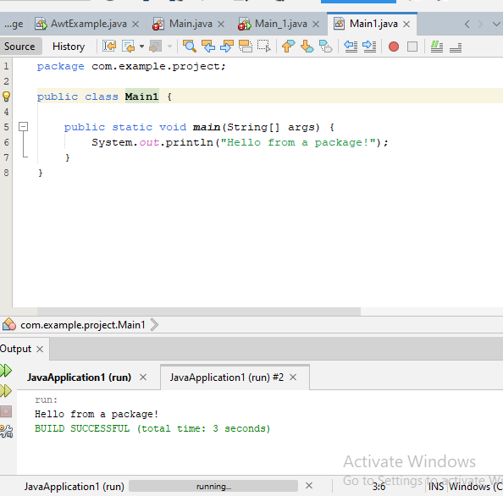

# Q2.

class ThreadDemo extends Thread {

@Override

public void run() {

try {

// Moving thread to Timed Waiting state

Thread.sleep(150); // Use 'sleep' method with 'Thread' prefix

} catch (InterruptedException e) {

e.printStackTrace();

}

System.out.println("State after completion: " + Thread.currentThread().getState());

}

public static void main(String[] args) throws InterruptedException {

ThreadDemo t1 = new ThreadDemo(); // Correct variable name

System.out.println("State when created: " + t1.getState()); // Correct variable name

t1.start(); // Correct variable name

System.out.println("State when started: " + t1.getState()); // Correct variable name

// Waiting for thread to die

t1.join();

System.out.println("State after thread ended its task: " + t1.getState()); // Correct variable name

}

}

## Output

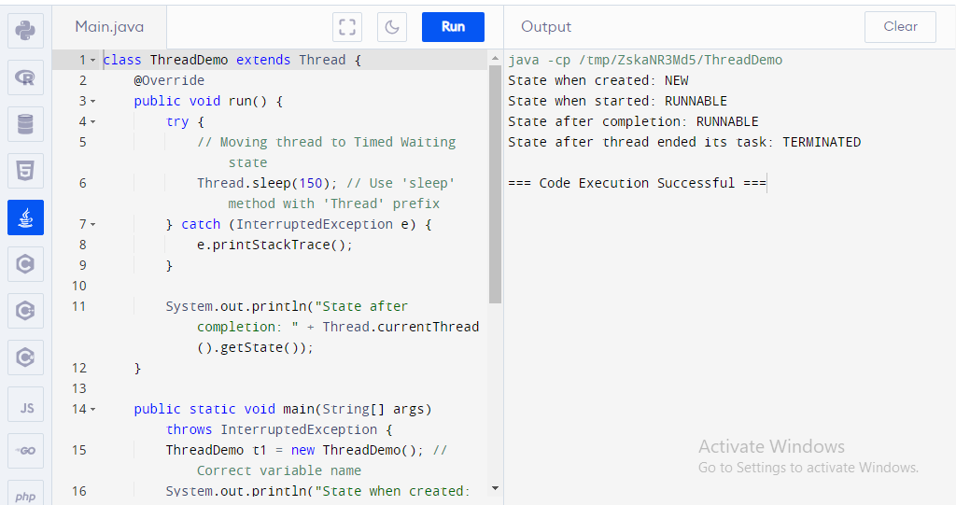

# Q3.

package com.example.project;

class InnerClass { // package-private class, not accessible outside 'com.example.project' package

void display() {

System.out.println("Hello from InnerClass");

}

}

public class Main {

public static void main(String[] args) {

InnerClass obj = new InnerClass();

obj.display();

}

}

## Output

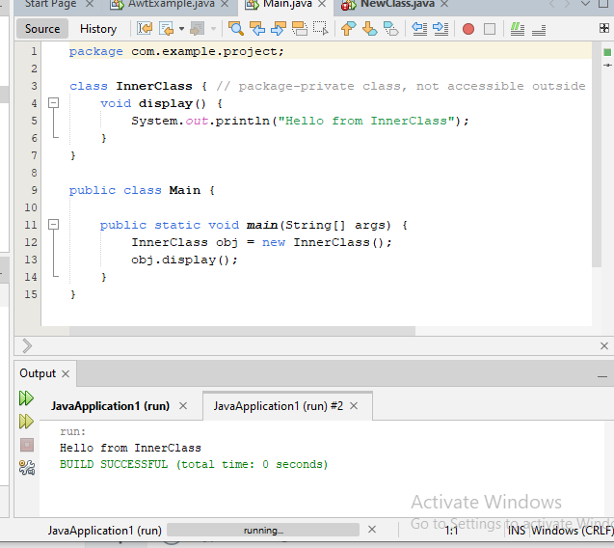

# Q4.

import java.awt.*;

import java.awt.event.*;

public class AwtExample extends Frame {

public AwtExample() {

// create a button

Button b = new Button("Click Me");

b.setBounds(100, 100, 80, 30); // setting button position

// add button to the frame

add(b);

setSize(300, 300); // frame size 300 width and 300 height

setLayout(null); // no layout manager

setVisible(true); // now frame will be visible

// close the frame when close button is clicked

addWindowListener(new WindowAdapter() {

public void windowClosing(WindowEvent e) {

dispose();

}

});

}

public static void main(String[] args) {

new AwtExample(); // creating instance

}

}

## Output

